УО «Белорусский государственный университет информатики и радиоэлектроники»

Кафедра ПОИТ

Отчет по лабораторной работе №2

по предмету «Теория информации»

Вариант 3

Выполнил:

Журавский В.А.

Гр. 351003

Проверил:

Болтак С. В.

Минск 2025

**Демонстрация работы:**

Во всех программах будем использовать ключ, состоящий из исключительно единиц.

Проверим программу с помощью монохромного изображения в формате BMP (путь к файлу указан выше, некоторые данные указаны слева).

Исходное изображение:

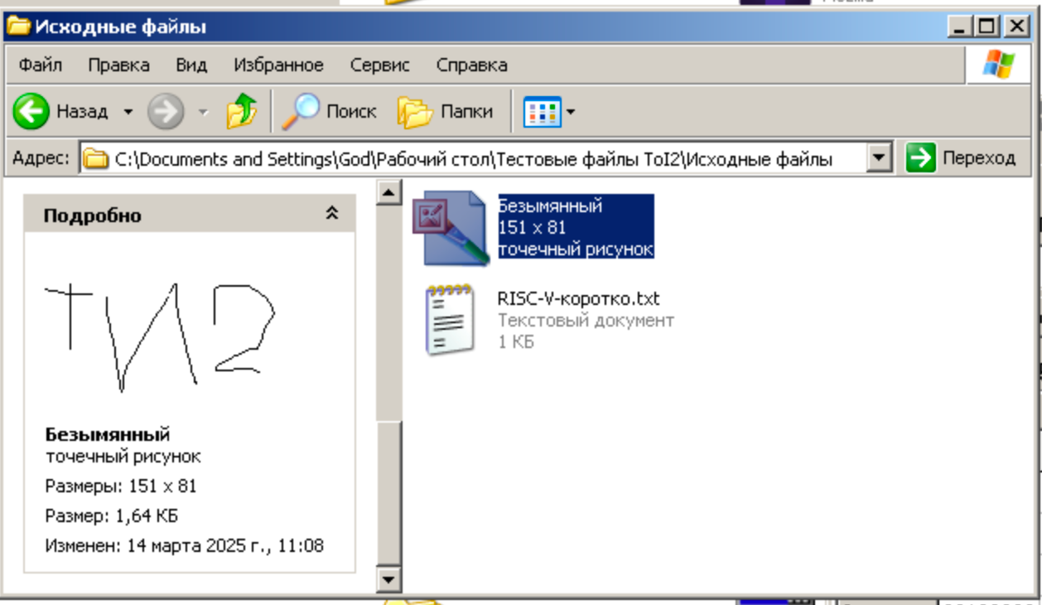

Шифрование (первые байты ключа и данных):

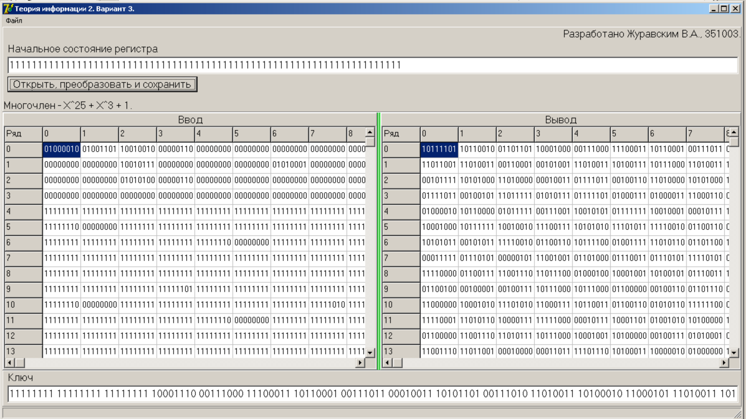

Шифрование (последние байты ключа и данных):

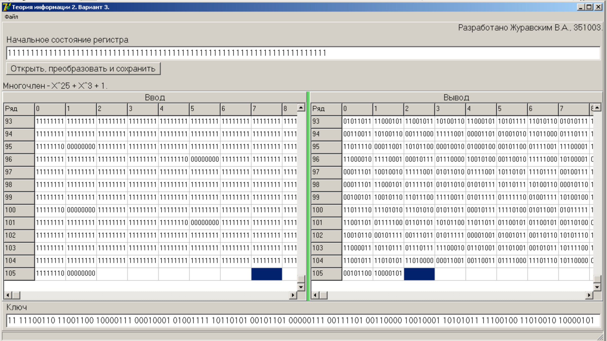

Зашифрованный файл (расширение программа подставляет автоматически):

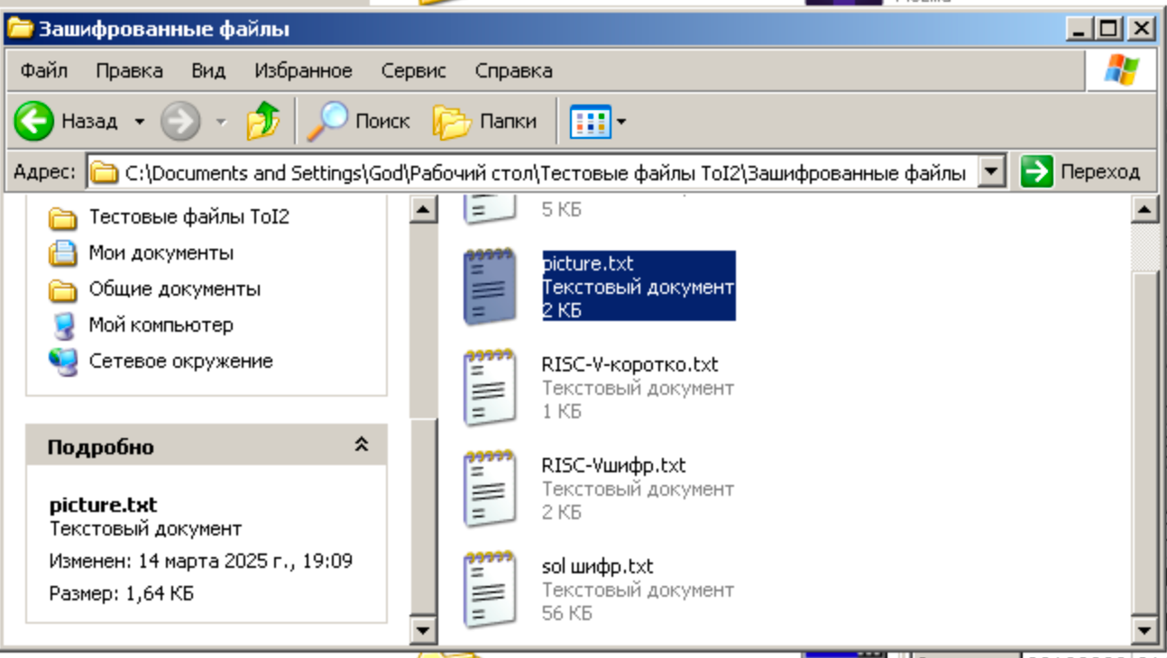

Дешифрование (первые байты ключа и данных):

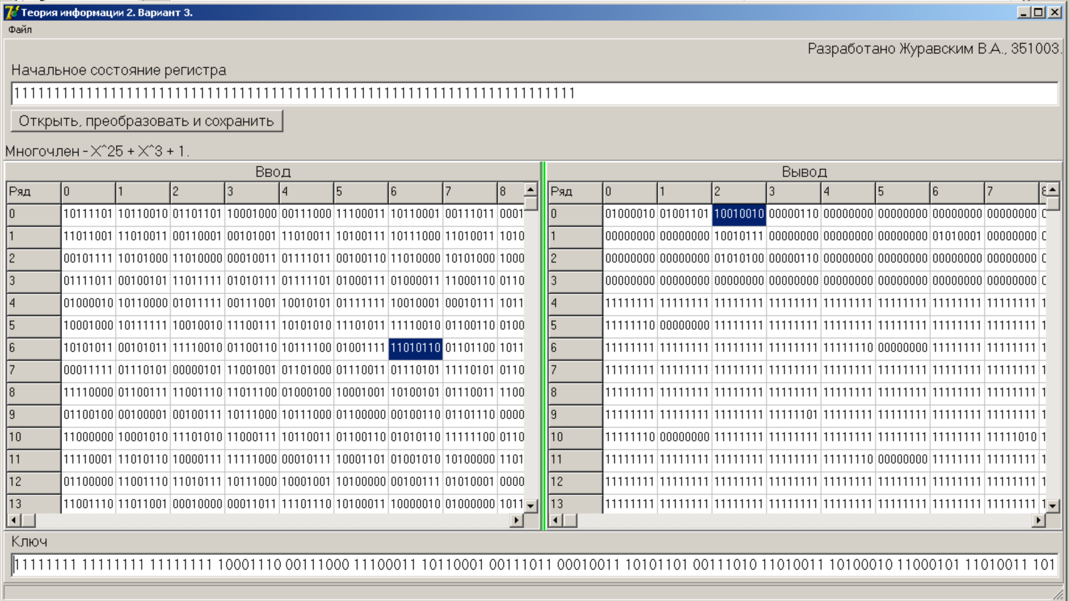

Дешифрование (последние байты ключа и данных):

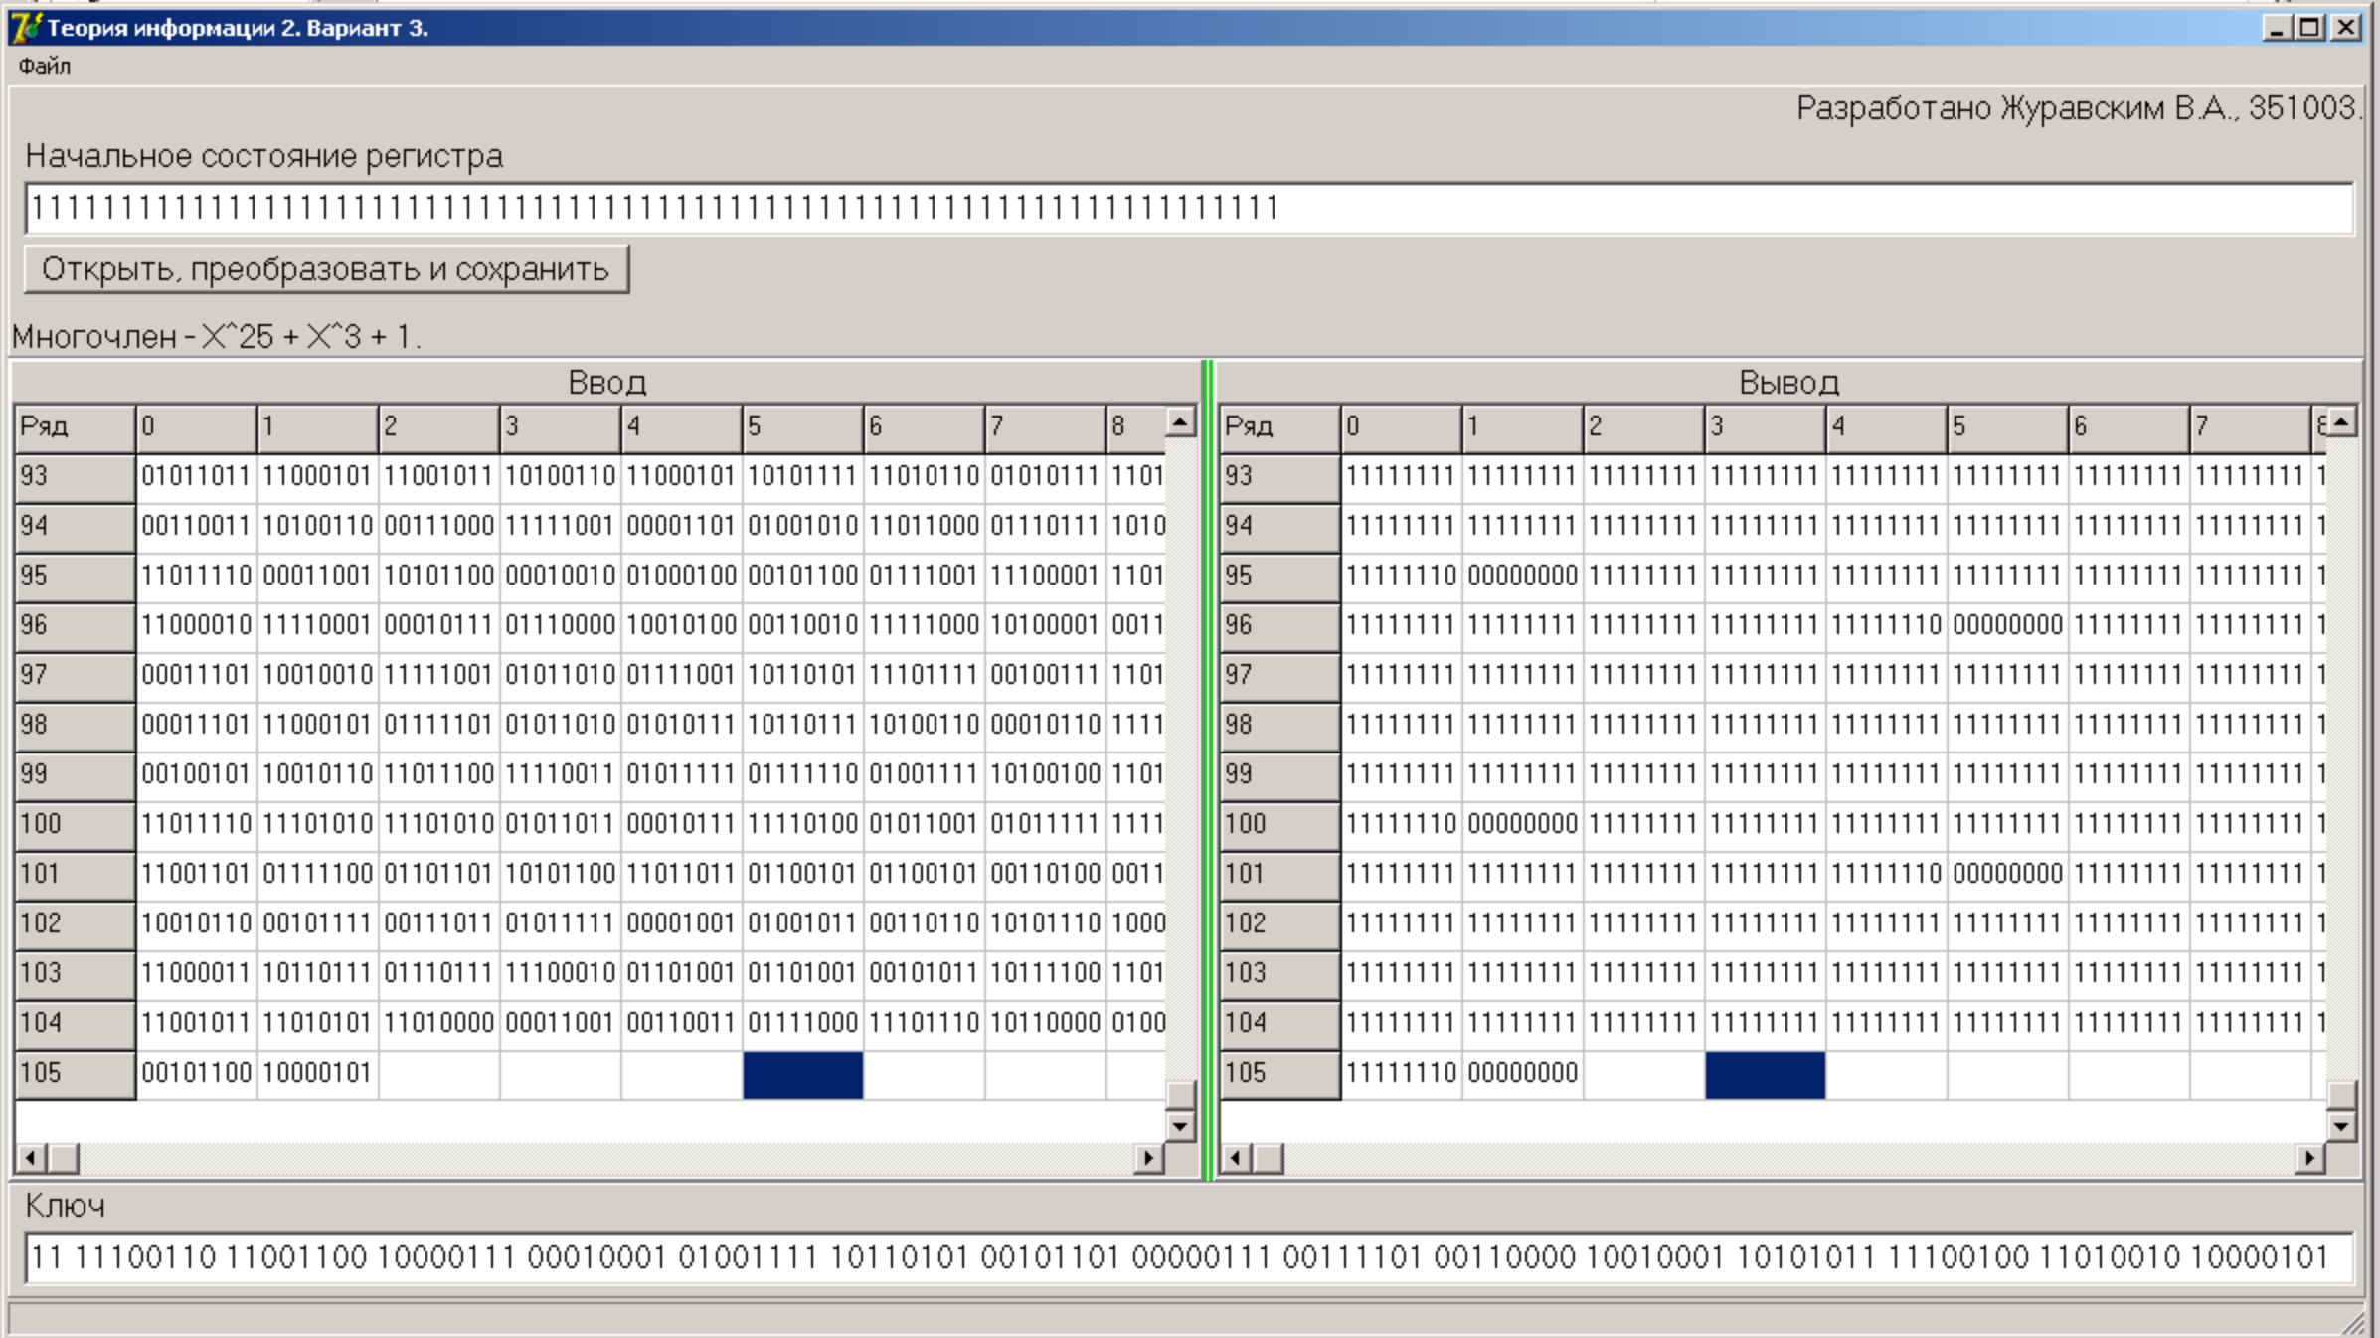

Расшифрованный файл:

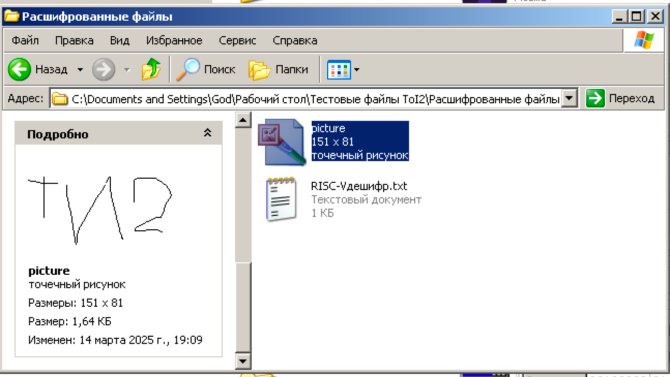

Проверим программу с помощью текстового файла следующего содержания:

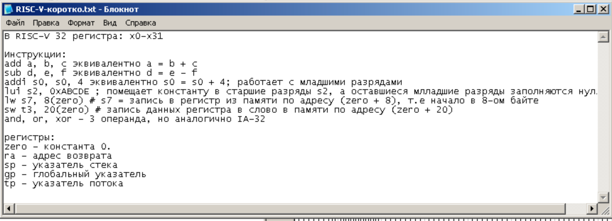

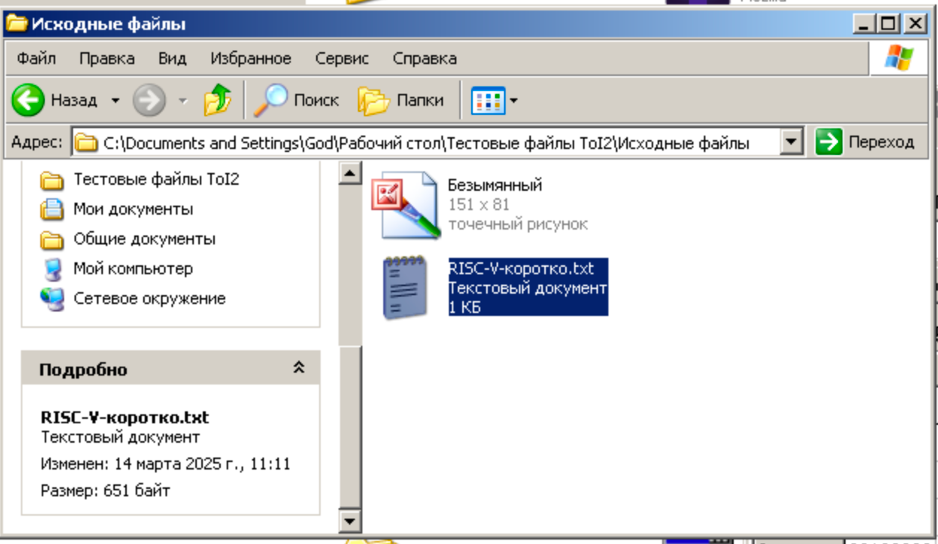

Шифрование (первые байты ключа и данных):

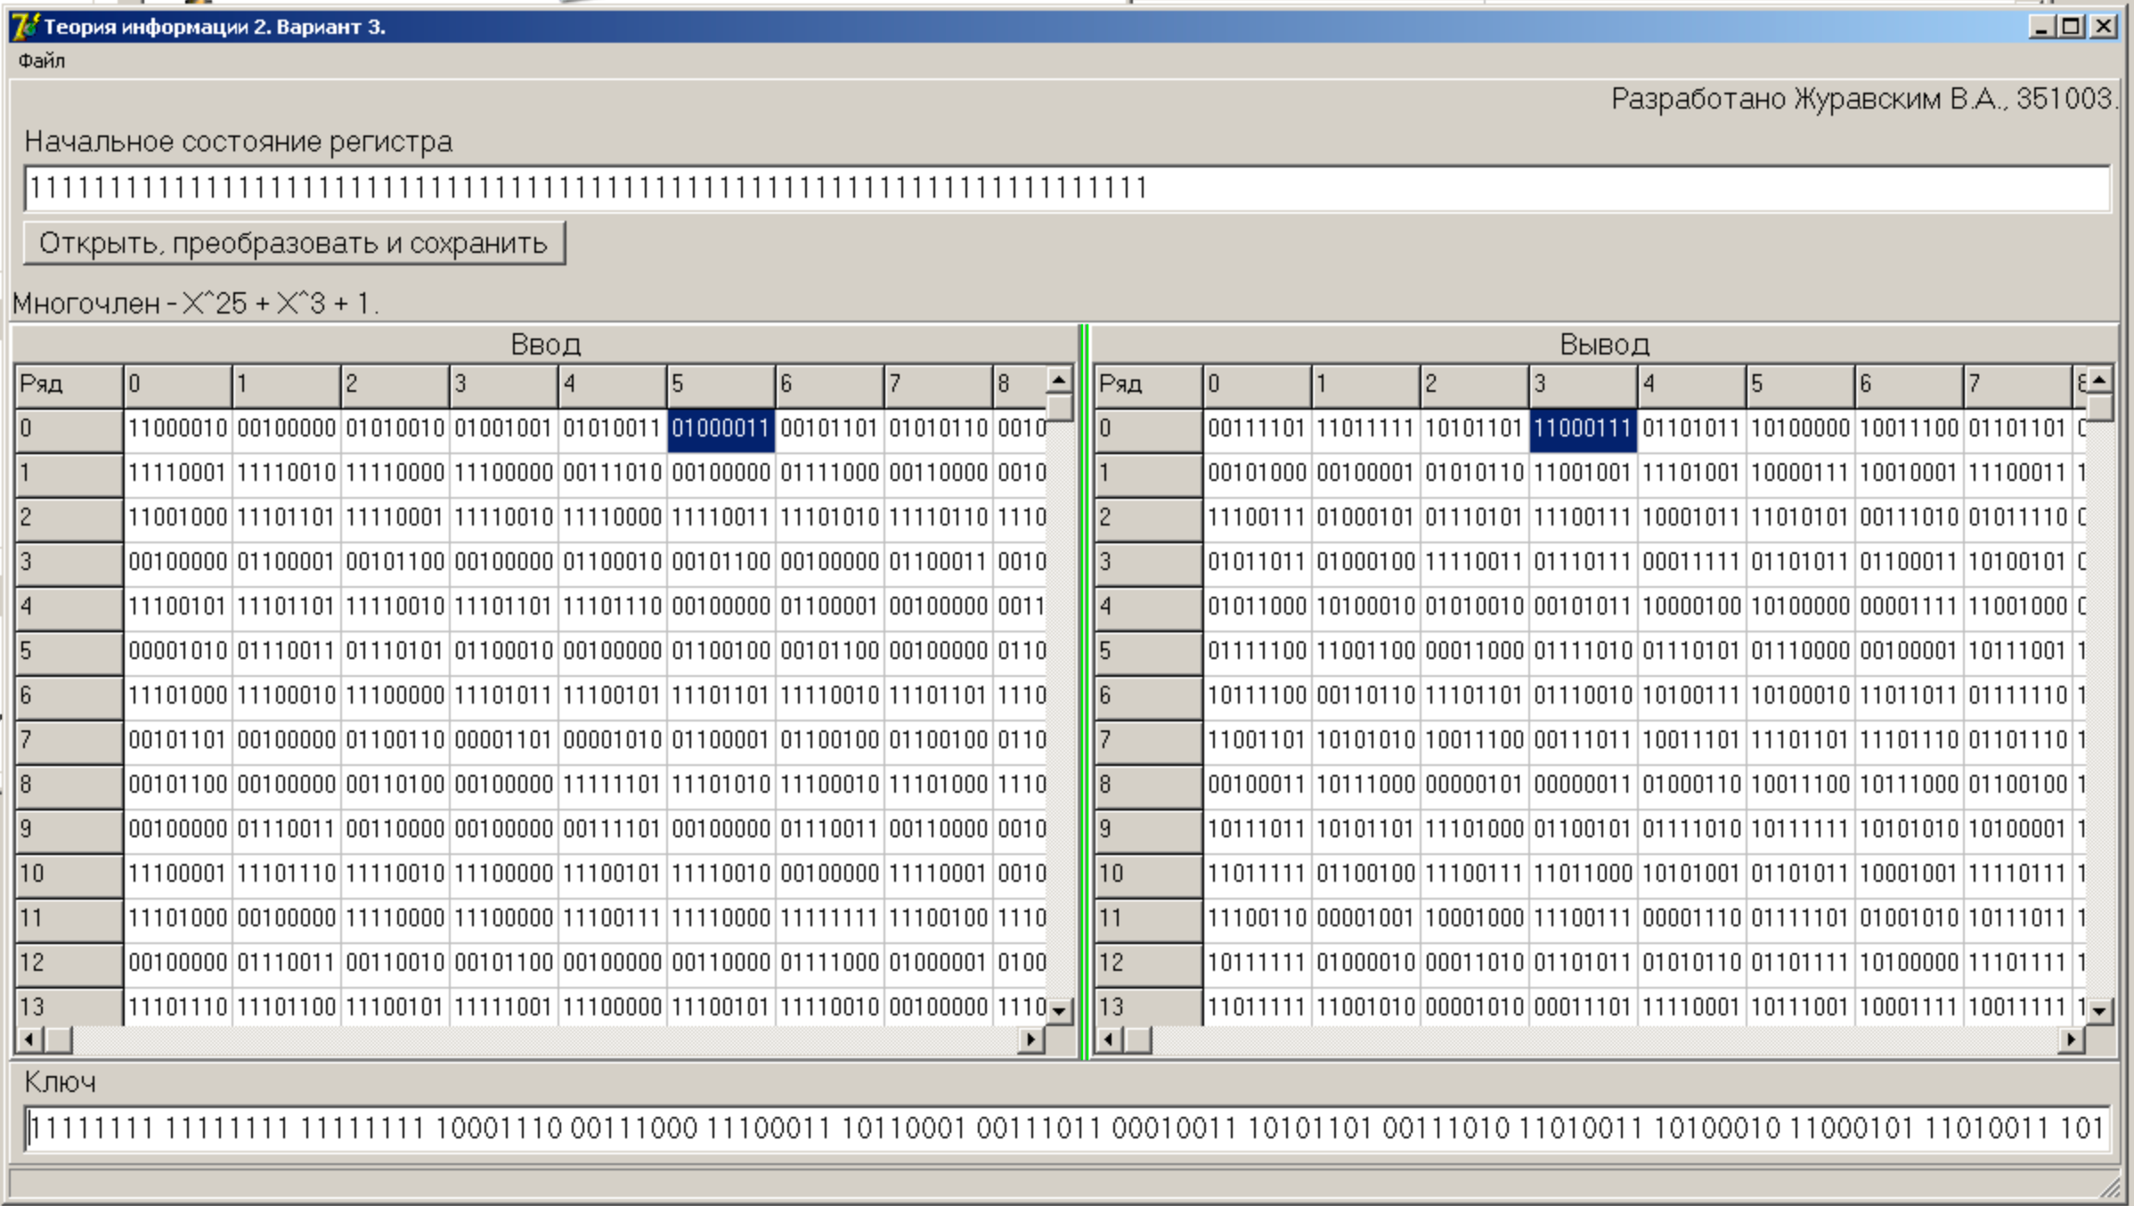

Шифрование (последние байты ключа и данных):

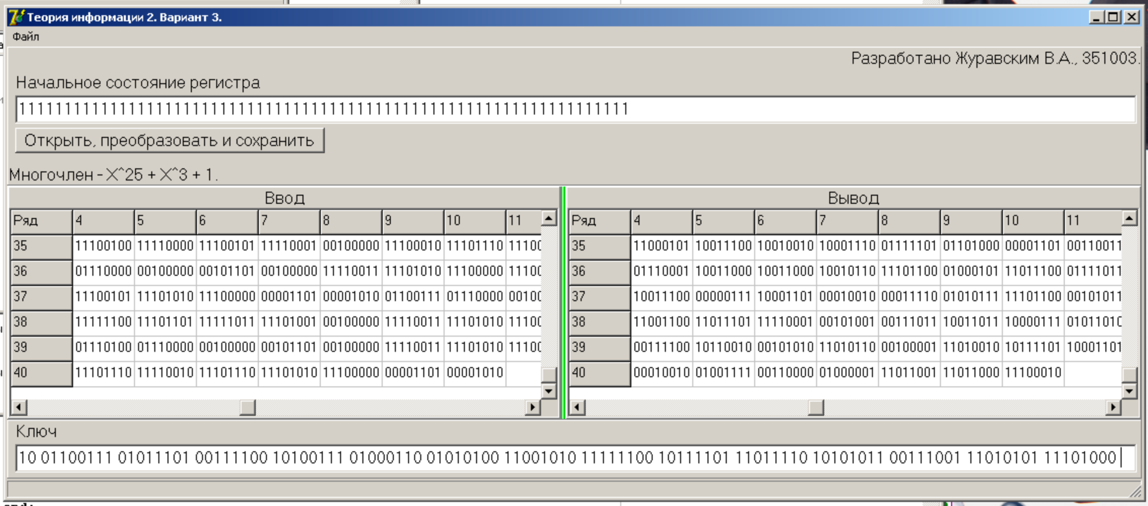

Зашифрованный файл:

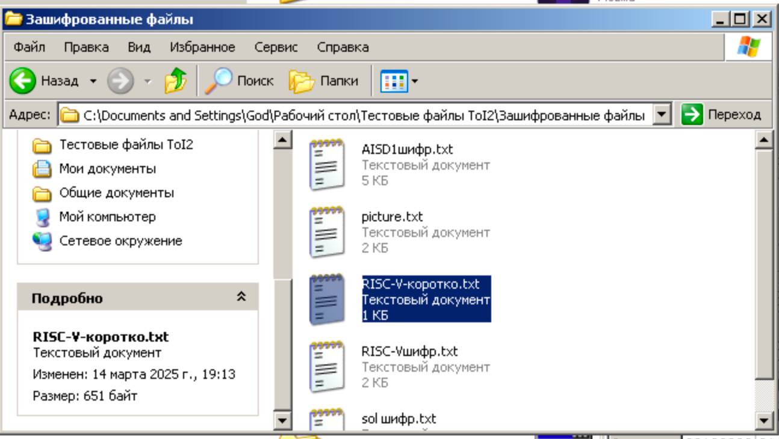

Дешифрование (первые байты ключа и данных):

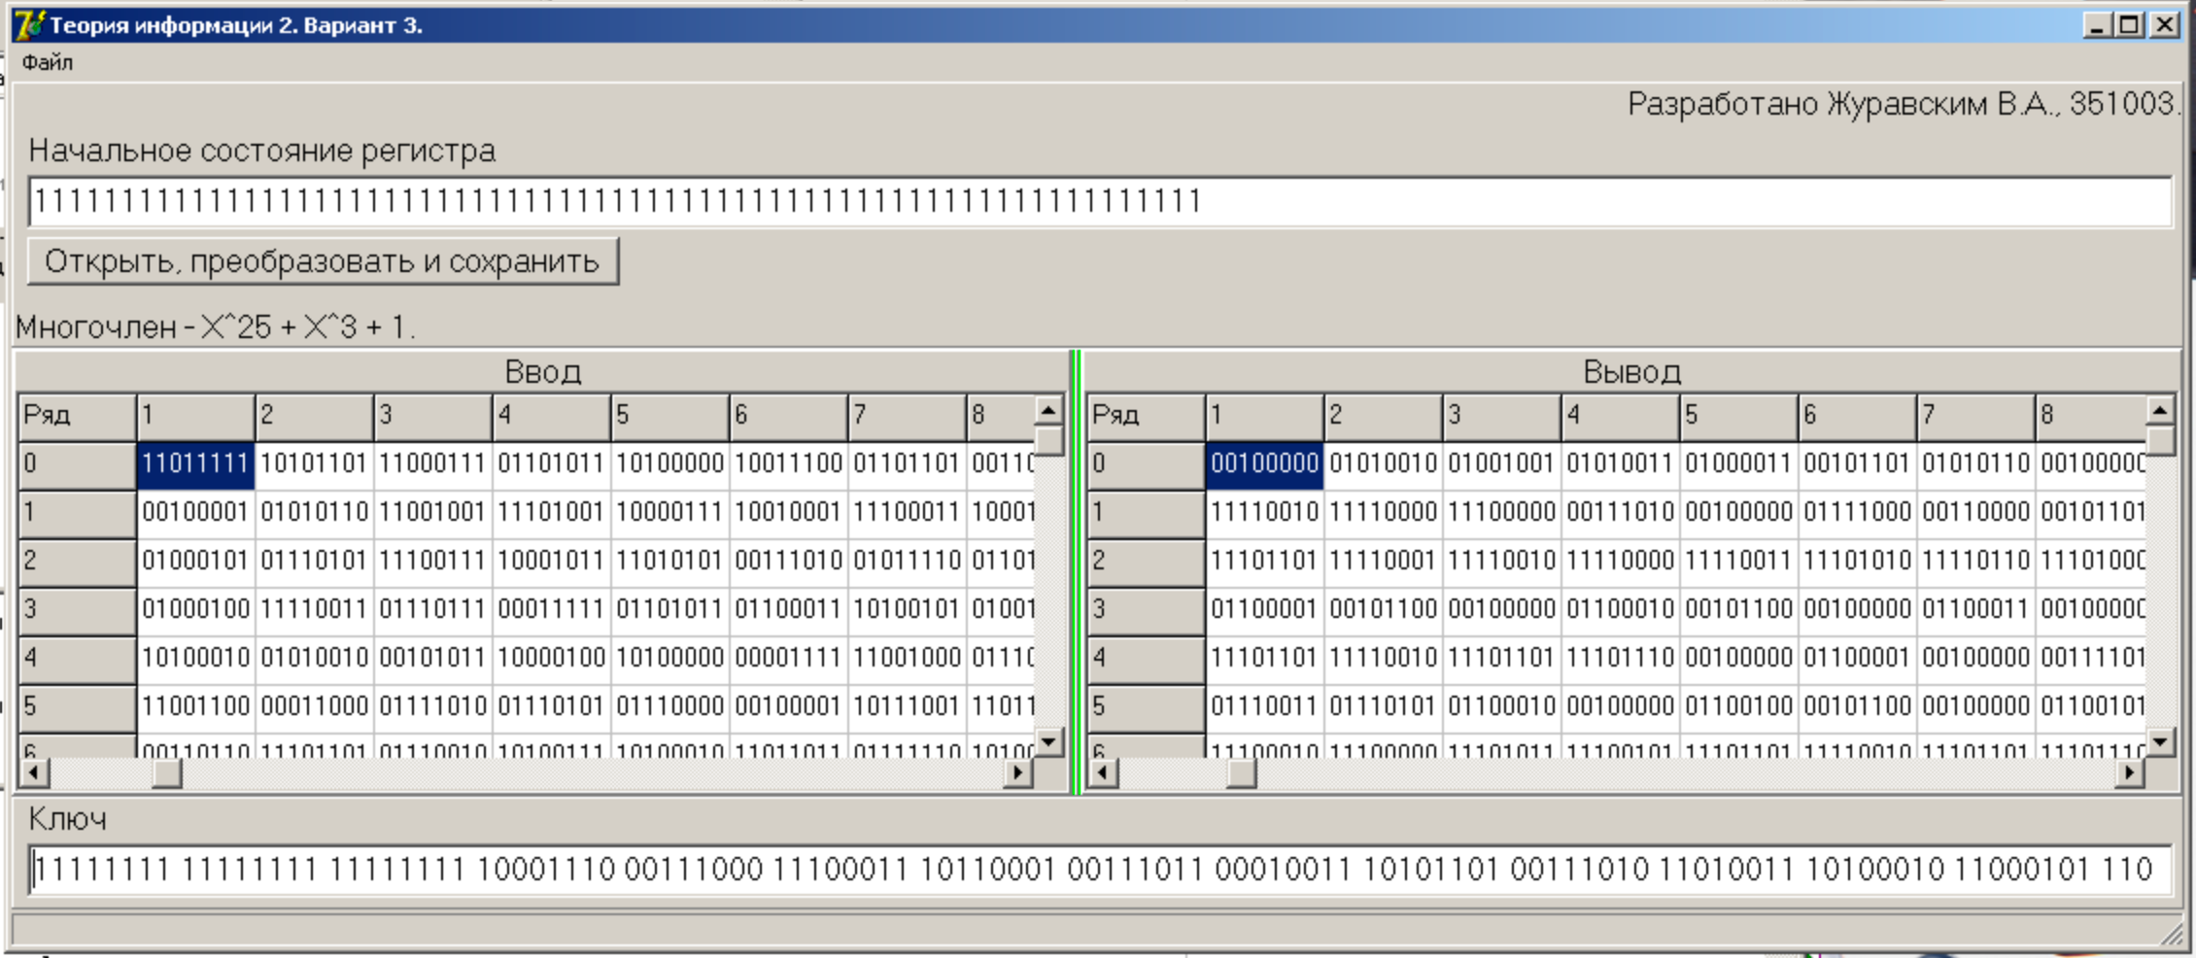

Дешифрование (последние байты ключа и данных):

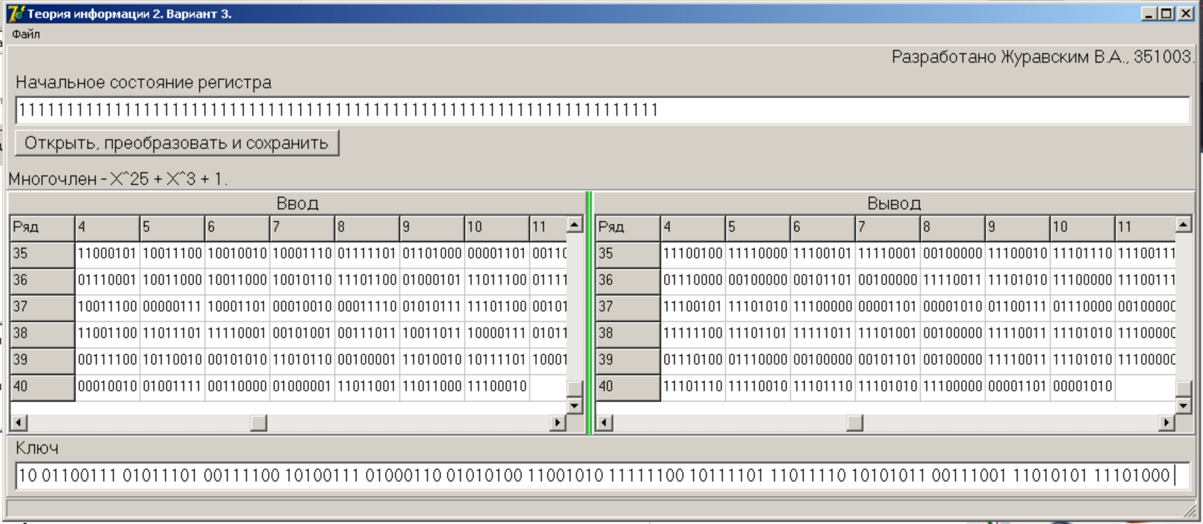

Расшифрованный файл:

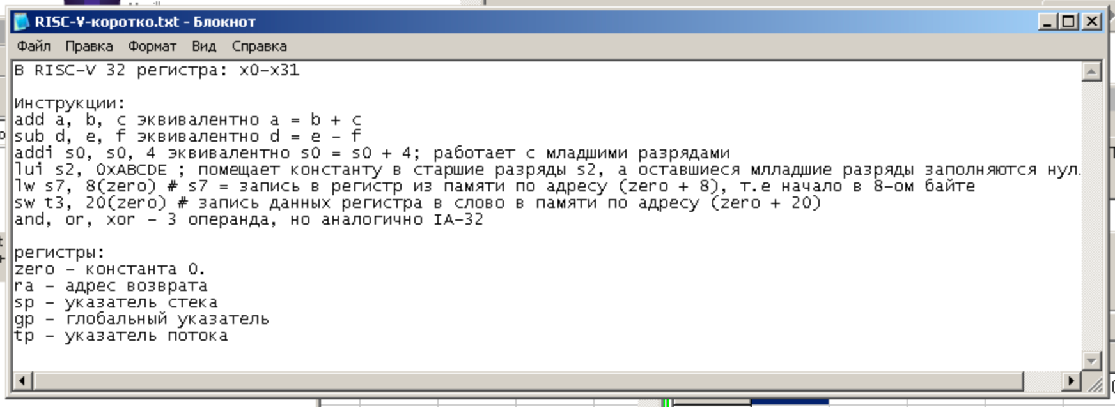

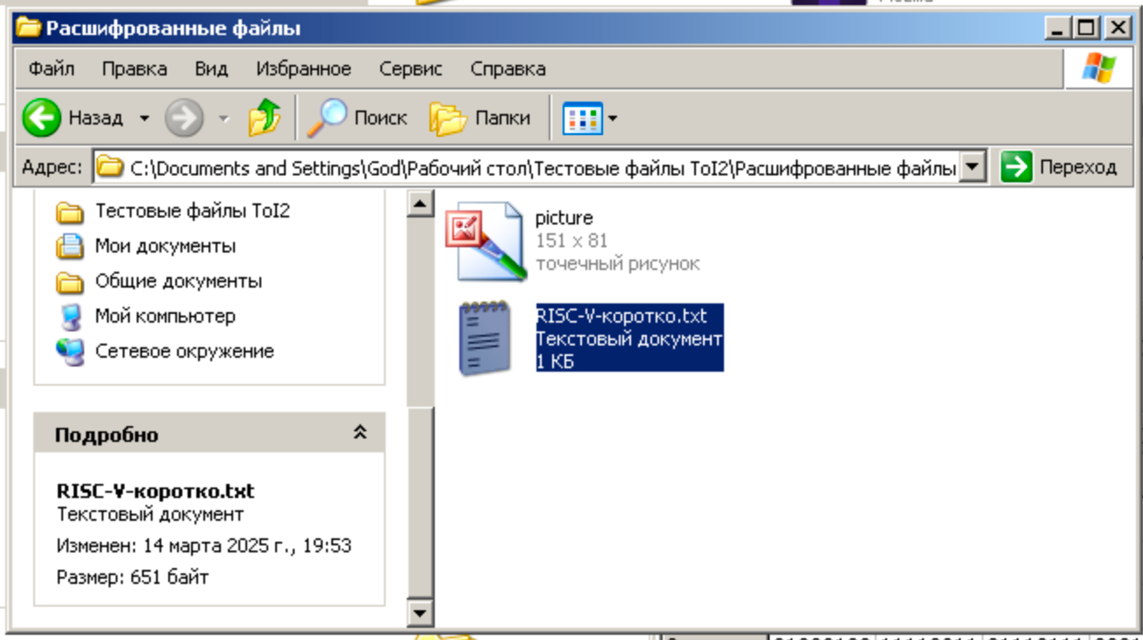

**Таблица:**

|  |  |  |  |  |  |  |  |  |  |  |  |  |  |  |  |  |  |  |  |  |  |  |  |  |  |  |
| --- | --- | --- | --- | --- | --- | --- | --- | --- | --- | --- | --- | --- | --- | --- | --- | --- | --- | --- | --- | --- | --- | --- | --- | --- | --- | --- |
| Шаг | Примитивный многочлен | | | | | | | | | | | | | | | | | | | | | | | | | XOR |
| 1 | 0 | 0 | 0 | 0 | 0 | 0 | 0 | 0 | 0 | 0 | 0 | 0 | 0 | 0 | 0 | 0 | 0 | 0 | 0 | 0 | 0 | 1 | 0 | 0 |
| Степени | | | | | | | | | | | | | | | | | | | | | | | | |
| 25 | 24 | 23 | 22 | 21 | 20 | 19 | 18 | 17 | 16 | 15 | 14 | 13 | 12 | 11 | 10 | 9 | 8 | 7 | 6 | 5 | 4 | 3 | 2 | 1 |
| 0 | 1 | 1 | 1 | 1 | 1 | 1 | 1 | 1 | 1 | 1 | 1 | 1 | 1 | 1 | 1 | 1 | 1 | 1 | 1 | 1 | 1 | 1 | 1 | 1 | 1 | 0 |
| 1 | 1 | 1 | 1 | 1 | 1 | 1 | 1 | 1 | 1 | 1 | 1 | 1 | 1 | 1 | 1 | 1 | 1 | 1 | 1 | 1 | 1 | 1 | 1 | 1 | 0 | 0 |
| 2 | 1 | 1 | 1 | 1 | 1 | 1 | 1 | 1 | 1 | 1 | 1 | 1 | 1 | 1 | 1 | 1 | 1 | 1 | 1 | 1 | 1 | 1 | 1 | 0 | 0 | 0 |
| 3 | 1 | 1 | 1 | 1 | 1 | 1 | 1 | 1 | 1 | 1 | 1 | 1 | 1 | 1 | 1 | 1 | 1 | 1 | 1 | 1 | 1 | 1 | 0 | 0 | 0 | 1 |
| 4 | 1 | 1 | 1 | 1 | 1 | 1 | 1 | 1 | 1 | 1 | 1 | 1 | 1 | 1 | 1 | 1 | 1 | 1 | 1 | 1 | 1 | 0 | 0 | 0 | 1 | 1 |
| 5 | 1 | 1 | 1 | 1 | 1 | 1 | 1 | 1 | 1 | 1 | 1 | 1 | 1 | 1 | 1 | 1 | 1 | 1 | 1 | 1 | 0 | 0 | 0 | 1 | 1 | 1 |
| 6 | 1 | 1 | 1 | 1 | 1 | 1 | 1 | 1 | 1 | 1 | 1 | 1 | 1 | 1 | 1 | 1 | 1 | 1 | 1 | 0 | 0 | 0 | 1 | 1 | 1 | 0 |
| 7 | 1 | 1 | 1 | 1 | 1 | 1 | 1 | 1 | 1 | 1 | 1 | 1 | 1 | 1 | 1 | 1 | 1 | 1 | 0 | 0 | 0 | 1 | 1 | 1 | 0 | 0 |
| 8 | 1 | 1 | 1 | 1 | 1 | 1 | 1 | 1 | 1 | 1 | 1 | 1 | 1 | 1 | 1 | 1 | 1 | 0 | 0 | 0 | 1 | 1 | 1 | 0 | 0 | 0 |
| 9 | 1 | 1 | 1 | 1 | 1 | 1 | 1 | 1 | 1 | 1 | 1 | 1 | 1 | 1 | 1 | 1 | 0 | 0 | 0 | 1 | 1 | 1 | 0 | 0 | 0 | 1 |
| 10 | 1 | 1 | 1 | 1 | 1 | 1 | 1 | 1 | 1 | 1 | 1 | 1 | 1 | 1 | 1 | 0 | 0 | 0 | 1 | 1 | 1 | 0 | 0 | 0 | 1 | 1 |
| 11 | 1 | 1 | 1 | 1 | 1 | 1 | 1 | 1 | 1 | 1 | 1 | 1 | 1 | 1 | 0 | 0 | 0 | 1 | 1 | 1 | 0 | 0 | 0 | 1 | 1 | 1 |
| 12 | 1 | 1 | 1 | 1 | 1 | 1 | 1 | 1 | 1 | 1 | 1 | 1 | 1 | 0 | 0 | 0 | 1 | 1 | 1 | 0 | 0 | 0 | 1 | 1 | 1 | 0 |
| 13 | 1 | 1 | 1 | 1 | 1 | 1 | 1 | 1 | 1 | 1 | 1 | 1 | 0 | 0 | 0 | 1 | 1 | 1 | 0 | 0 | 0 | 1 | 1 | 1 | 0 | 0 |
| 14 | 1 | 1 | 1 | 1 | 1 | 1 | 1 | 1 | 1 | 1 | 1 | 0 | 0 | 0 | 1 | 1 | 1 | 0 | 0 | 0 | 1 | 1 | 1 | 0 | 0 | 0 |
| 15 | 1 | 1 | 1 | 1 | 1 | 1 | 1 | 1 | 1 | 1 | 0 | 0 | 0 | 1 | 1 | 1 | 0 | 0 | 0 | 1 | 1 | 1 | 0 | 0 | 0 | 1 |
| 16 | 1 | 1 | 1 | 1 | 1 | 1 | 1 | 1 | 1 | 0 | 0 | 0 | 1 | 1 | 1 | 0 | 0 | 0 | 1 | 1 | 1 | 0 | 0 | 0 | 1 | 1 |
| 17 | 1 | 1 | 1 | 1 | 1 | 1 | 1 | 1 | 0 | 0 | 0 | 1 | 1 | 1 | 0 | 0 | 0 | 1 | 1 | 1 | 0 | 0 | 0 | 1 | 1 | 1 |
| 18 | 1 | 1 | 1 | 1 | 1 | 1 | 1 | 0 | 0 | 0 | 1 | 1 | 1 | 0 | 0 | 0 | 1 | 1 | 1 | 0 | 0 | 0 | 1 | 1 | 1 | 0 |
| 19 | 1 | 1 | 1 | 1 | 1 | 1 | 0 | 0 | 0 | 1 | 1 | 1 | 0 | 0 | 0 | 1 | 1 | 1 | 0 | 0 | 0 | 1 | 1 | 1 | 0 | 0 |
| 20 | 1 | 1 | 1 | 1 | 1 | 0 | 0 | 0 | 1 | 1 | 1 | 0 | 0 | 0 | 1 | 1 | 1 | 0 | 0 | 0 | 1 | 1 | 1 | 0 | 0 | 0 |
| 21 | 1 | 1 | 1 | 1 | 0 | 0 | 0 | 1 | 1 | 1 | 0 | 0 | 0 | 1 | 1 | 1 | 0 | 0 | 0 | 1 | 1 | 1 | 0 | 0 | 0 | 1 |
| 22 | 1 | 1 | 1 | 0 | 0 | 0 | 1 | 1 | 1 | 0 | 0 | 0 | 1 | 1 | 1 | 0 | 0 | 0 | 1 | 1 | 1 | 0 | 0 | 0 | 1 | 1 |
| 23 | 1 | 1 | 0 | 0 | 0 | 1 | 1 | 1 | 0 | 0 | 0 | 1 | 1 | 1 | 0 | 0 | 0 | 1 | 1 | 1 | 0 | 0 | 0 | 1 | 1 | 1 |
| 24 | 1 | 0 | 0 | 0 | 1 | 1 | 1 | 0 | 0 | 0 | 1 | 1 | 1 | 0 | 0 | 0 | 1 | 1 | 1 | 0 | 0 | 0 | 1 | 1 | 1 | 0 |
| 25 | 0 | 0 | 0 | 1 | 1 | 1 | 0 | 0 | 0 | 1 | 1 | 1 | 0 | 0 | 0 | 1 | 1 | 1 | 0 | 0 | 0 | 1 | 1 | 1 | 0 | 1 |
| 26 | 0 | 0 | 1 | 1 | 1 | 0 | 0 | 0 | 1 | 1 | 1 | 0 | 0 | 0 | 1 | 1 | 1 | 0 | 0 | 0 | 1 | 1 | 1 | 0 | 1 | 1 |
| 27 | 0 | 1 | 1 | 1 | 0 | 0 | 0 | 1 | 1 | 1 | 0 | 0 | 0 | 1 | 1 | 1 | 0 | 0 | 0 | 1 | 1 | 1 | 0 | 1 | 1 | 0 |
| 28 | 1 | 1 | 1 | 0 | 0 | 0 | 1 | 1 | 1 | 0 | 0 | 0 | 1 | 1 | 1 | 0 | 0 | 0 | 1 | 1 | 1 | 0 | 1 | 1 | 0 | 0 |
| 29 | 1 | 1 | 0 | 0 | 0 | 1 | 1 | 1 | 0 | 0 | 0 | 1 | 1 | 1 | 0 | 0 | 0 | 1 | 1 | 1 | 0 | 1 | 1 | 0 | 0 | 0 |
| 30 | 1 | 0 | 0 | 0 | 1 | 1 | 1 | 0 | 0 | 0 | 1 | 1 | 1 | 0 | 0 | 0 | 1 | 1 | 1 | 0 | 1 | 1 | 0 | 0 | 0 | 1 |
| 31 | 0 | 0 | 0 | 1 | 1 | 1 | 0 | 0 | 0 | 1 | 1 | 1 | 0 | 0 | 0 | 1 | 1 | 1 | 0 | 1 | 1 | 0 | 0 | 0 | 1 | 0 |
| 32 | 0 | 0 | 1 | 1 | 1 | 0 | 0 | 0 | 1 | 1 | 1 | 0 | 0 | 0 | 1 | 1 | 1 | 0 | 1 | 1 | 0 | 0 | 0 | 1 | 0 | 0 |
| 33 | 0 | 1 | 1 | 1 | 0 | 0 | 0 | 1 | 1 | 1 | 0 | 0 | 0 | 1 | 1 | 1 | 0 | 1 | 1 | 0 | 0 | 0 | 1 | 0 | 0 | 1 |
| 34 | 1 | 1 | 1 | 0 | 0 | 0 | 1 | 1 | 1 | 0 | 0 | 0 | 1 | 1 | 1 | 0 | 1 | 1 | 0 | 0 | 0 | 1 | 0 | 0 | 1 | 1 |
| 35 | 1 | 1 | 0 | 0 | 0 | 1 | 1 | 1 | 0 | 0 | 0 | 1 | 1 | 1 | 0 | 1 | 1 | 0 | 0 | 0 | 1 | 0 | 0 | 1 | 1 | 1 |
| 36 | 1 | 0 | 0 | 0 | 1 | 1 | 1 | 0 | 0 | 0 | 1 | 1 | 1 | 0 | 1 | 1 | 0 | 0 | 0 | 1 | 0 | 0 | 1 | 1 | 1 | 0 |
| 37 | 0 | 0 | 0 | 1 | 1 | 1 | 0 | 0 | 0 | 1 | 1 | 1 | 0 | 1 | 1 | 0 | 0 | 0 | 1 | 0 | 0 | 1 | 1 | 1 | 0 | 1 |
| 38 | 0 | 0 | 1 | 1 | 1 | 0 | 0 | 0 | 1 | 1 | 1 | 0 | 1 | 1 | 0 | 0 | 0 | 1 | 0 | 0 | 1 | 1 | 1 | 0 | 1 | 1 |
| 39 | 0 | 1 | 1 | 1 | 0 | 0 | 0 | 1 | 1 | 1 | 0 | 1 | 1 | 0 | 0 | 0 | 1 | 0 | 0 | 1 | 1 | 1 | 0 | 1 | 1 | 0 |
| 40 | 1 | 1 | 1 | 0 | 0 | 0 | 1 | 1 | 1 | 0 | 1 | 1 | 0 | 0 | 0 | 1 | 0 | 0 | 1 | 1 | 1 | 0 | 1 | 1 | 0 | 0 |
| 41 | 1 | 1 | 0 | 0 | 0 | 1 | 1 | 1 | 0 | 1 | 1 | 0 | 0 | 0 | 1 | 0 | 0 | 1 | 1 | 1 | 0 | 1 | 1 | 0 | 0 | 0 |
| 42 | 1 | 0 | 0 | 0 | 1 | 1 | 1 | 0 | 1 | 1 | 0 | 0 | 0 | 1 | 0 | 0 | 1 | 1 | 1 | 0 | 1 | 1 | 0 | 0 | 0 | 1 |
| 43 | 0 | 0 | 0 | 1 | 1 | 1 | 0 | 1 | 1 | 0 | 0 | 0 | 1 | 0 | 0 | 1 | 1 | 1 | 0 | 1 | 1 | 0 | 0 | 0 | 1 | 0 |
| 44 | 0 | 0 | 1 | 1 | 1 | 0 | 1 | 1 | 0 | 0 | 0 | 1 | 0 | 0 | 1 | 1 | 1 | 0 | 1 | 1 | 0 | 0 | 0 | 1 | 0 | 0 |
| 45 | 0 | 1 | 1 | 1 | 0 | 1 | 1 | 0 | 0 | 0 | 1 | 0 | 0 | 1 | 1 | 1 | 0 | 1 | 1 | 0 | 0 | 0 | 1 | 0 | 0 | 1 |
| 46 | 1 | 1 | 1 | 0 | 1 | 1 | 0 | 0 | 0 | 1 | 0 | 0 | 1 | 1 | 1 | 0 | 1 | 1 | 0 | 0 | 0 | 1 | 0 | 0 | 1 | 1 |
| 47 | 1 | 1 | 0 | 1 | 1 | 0 | 0 | 0 | 1 | 0 | 0 | 1 | 1 | 1 | 0 | 1 | 1 | 0 | 0 | 0 | 1 | 0 | 0 | 1 | 1 | 1 |
| 48 | 1 | 0 | 1 | 1 | 0 | 0 | 0 | 1 | 0 | 0 | 1 | 1 | 1 | 0 | 1 | 1 | 0 | 0 | 0 | 1 | 0 | 0 | 1 | 1 | 1 | 0 |
| 49 | 0 | 1 | 1 | 0 | 0 | 0 | 1 | 0 | 0 | 1 | 1 | 1 | 0 | 1 | 1 | 0 | 0 | 0 | 1 | 0 | 0 | 1 | 1 | 1 | 0 | 1 |
| 50 | 1 | 1 | 0 | 0 | 0 | 1 | 0 | 0 | 1 | 1 | 1 | 0 | 1 | 1 | 0 | 0 | 0 | 1 | 0 | 0 | 1 | 1 | 1 | 0 | 1 | 0 |
| 51 | 1 | 0 | 0 | 0 | 1 | 0 | 0 | 1 | 1 | 1 | 0 | 1 | 1 | 0 | 0 | 0 | 1 | 0 | 0 | 1 | 1 | 1 | 0 | 1 | 0 | 1 |